**Chapter 1: Interactive Schedul-**

**ing**

**Purpose and Scope of Interactive Scheduling** Schedule changes occur during the work day. Keeping the schedule up to date is essen- tial to maintain its quality and cost effectiveness. To accomplish this, Optibus OnSched-

ule™ provides an interactive manual editing facility. In addition, the manual editing

facility enables you to fine-tune the schedule.

This chapter shows you how to open elements in the Gantts for editing and make changes using their information boxes. Most manual editing will be on the Drivers Gantt. Edits to the Vehicles Gantt are limited. You can only reschedule a trip in the Vehicles Gantt for a Vehicles-only schedule.

What follows will be based on editing the Drivers Gantt for a full schedule. At the end of the chapter there is a short section on editing the Vehicles Gantt elements for a

Vehicles-only schedule.

You can test your edits one at a time. At any point you can save or discard your changes. The following editing actions available that can be used alone or in combination:

*Table 1-1: Interactive Editing Functions for a full schedule*

|  |  |  |  |  |
| --- | --- | --- | --- | --- |
| **Function** | **Drivers** | | **Vehicles** | |
| **Available** | **Reference in Drivers Gantt**  **Interactive Editing** | **Available** | **Reference in Vehicles**  **Gantt Interactive Editing** |
| Move a trip to another Duty | Yes | **Move a trip to another**  **Duty** | N/A |  |
| Changing trip times | Yes | **Changing trip times** | Yes | **Changing trip times** |
| Delete a trip or deadhead | Yes | **Delete a trip or dead- head** | Yes | **Delete a trip or dead- head** |
| Switch between Taxi and  Deadhead elements | Yes | **Switch between Taxi and**  **Deadhead elements** | N/A |  |
| Add new elements | Yes | **Add new elements** | No |  |
| Block functions |  | | | |
| Block ID | Yes, Duty  ID | **Change Duty ID** | Yes, Driver ID | **Change Vehicle ID** |
| Start/End stops | Yes | **Set Start/End stops** | No |  |
| Vehicle type | N/A |  | Yes | **Change Vehicle Type** |
| Move block up or down | Yes | **Move a block up or down** | Yes | **Move a block up or down** |
| Edit Stack functions |  | | | |
| De-assign a trip to the editing stack | Yes | **De-assign a trip to the editing stack** | No |  |
| Re-assign a trip from the edit- ing stack | Yes | **Restore a trip to the edit- ing stack** | No |  |
| Create a new trip | **Using Add Trip** | | | |

*Table 1-2: Interactive Editing Functions for a vehicles-only schedule*

|  |  |
| --- | --- |
| **Function** | **Reference in Using a Vehicles-only Schedule** |
| Move a trip to another vehicle | **Move a trip to another vehicle** |
| Changing trip times | **Changing trip times** |
| Delete a trip or deadhead | **Delete a trip or deadhead** |
| Add deadheads | **Adding Deadheads** |
| Block functions |  |
| Block ID | **Change Vehicle ID** |
| Vehicle type | **Change Vehicle Type** |
| Move block up or down | **Move a block up or down** |
| Create a new trip | **Using Add Trip** |

**Preparing for an Interactive Editing Session**

At the top of the Gantt display, you will have noticed that there is an option to save or dis- card your changes, for example after setting preferences or running an optimization:



The same applies to manual editing. Until you feel comfortable using manual editing, we suggest that you start by backing up your existing schedule using **Save As** from the Context Menu.



To enter Manual Editing mode, click the Manual Edit button in the top toolbar. An editing area (in the red box) called the **stack**, opens above the regular Gantt:

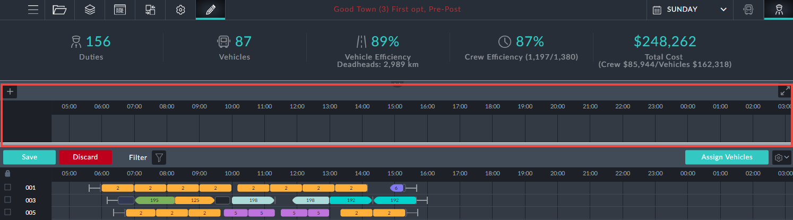

**Drivers Gantt Interactive Editing**

**What can and cannot be edited**

Trips can have their start/end times edited or be removed completely



Deadheads at the beginning and end of a duty can be edited or removed. Apart from deletion, these elements can be changed to a taxi and vice versa. Thus, pull outs and pull ins at the beginning and end of a duty can be edited. Those occurring in the middle of a duty cannot.



Other deadheads, split breaks, pre/post and sign on/off elements cannot be edited. Block information boxes offer editable fields: Driver ID and start/end locations for the



duty.

**Move a trip to another Duty**

It is required to move the red-boxed trip in duty 201 in the Drivers Gantt to a different duty:

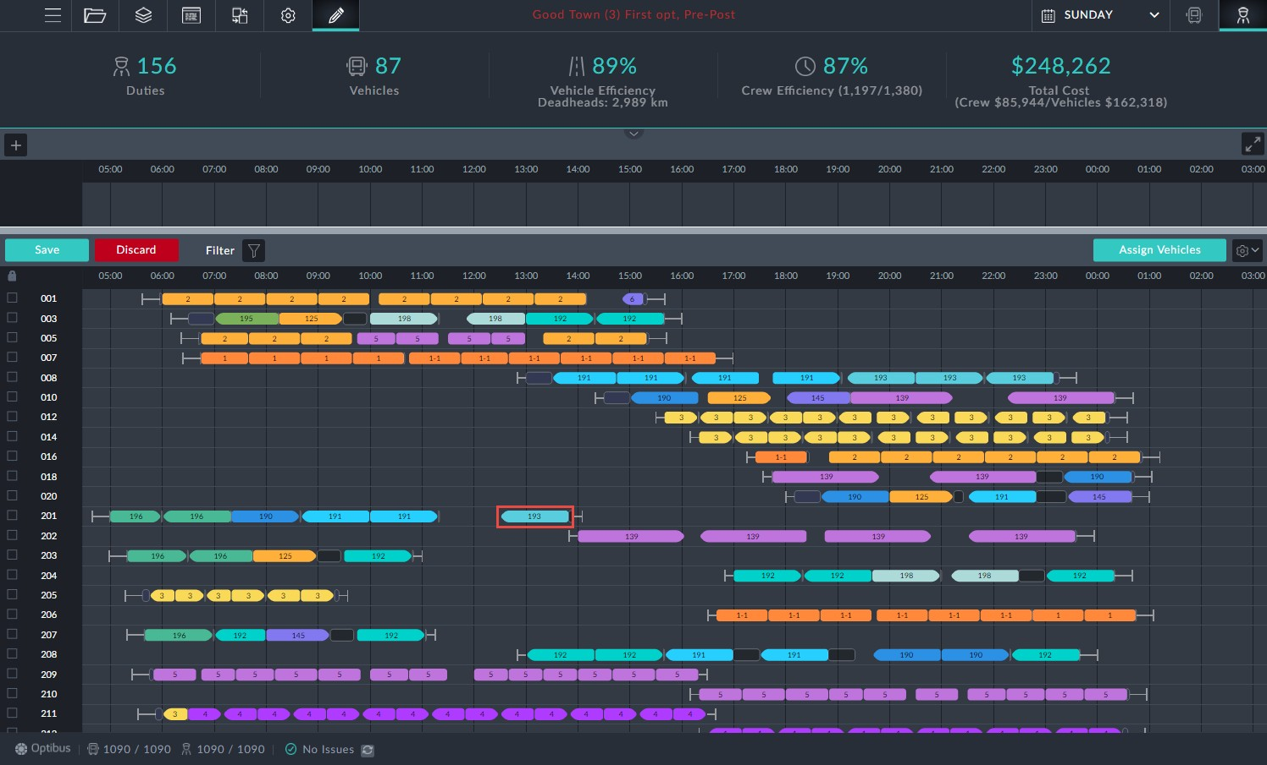

*Figure 1-1: Drivers Gantt prepared for manual editing*

Ø**To move a trip to another Duty:**

1. Enter Editing Mode as shown.

2. Double click the trip to be moved.

A shaded area including possible trip slots is displayed.

The system automatically recommends all possible options for relocation of the

trip. There are two indications for each option:

A blue frame indicates that preferences are honored.



A red frame for an option indicates a violation of preferences. Inside the frame is a quality rating: 1 to 5 stars.



3. At duty 10 there is a slot with four stars in a red border. Click it to opens its

information box:

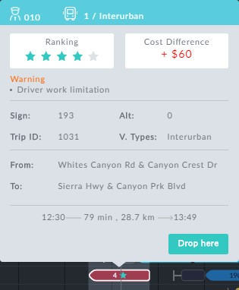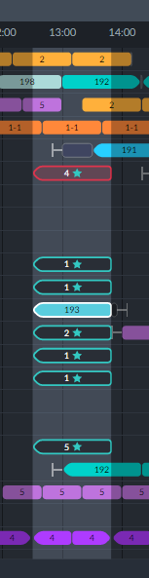

*Figure 1-2: Left: Eligible slots; Right: Problematic red bordered slot: Work limitation violation*

4. At the bottom of the eligible slots, there is one at duty 207 with a blue border and five stars. it is sufficient to double click it to move the trip.

Here is part of the changed Drivers Gantt showing the moved trip, shown in the red box. Notice also the new generated sign-off immediately after the trip.

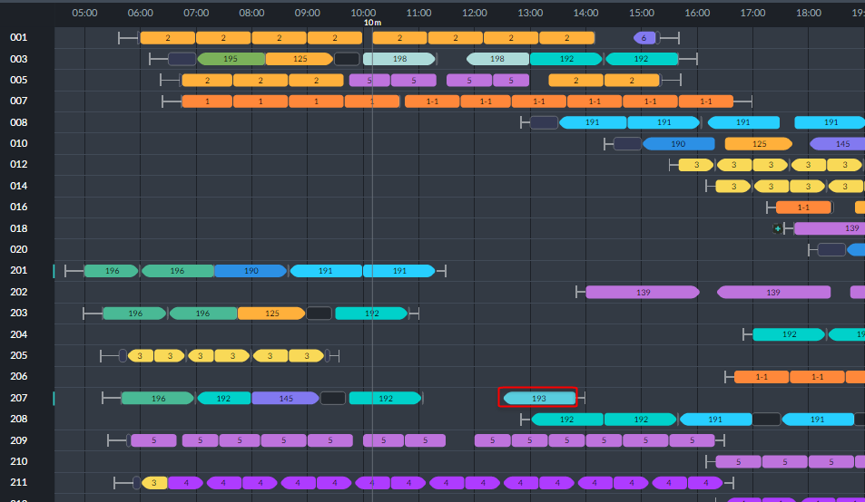

The re-assignment affects the Vehicles schedule: In the Vehicles Gantt, vehicle 3, (which

is slotted to do the new trip) and also vehicle 1:

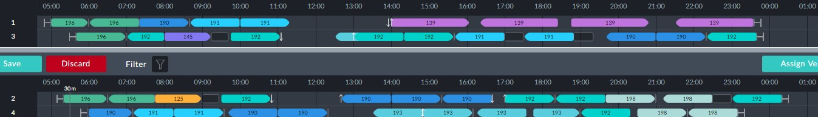

In the end vehicle 3 does not do it. To see the actual result, click the **Assign Vehicles** but- ton. We will not display it here. The new trip has been assigned to vehicle 88. An exam- ination of the KPIs shows that the change has increased the vehicles count from 87 to 89.



For advanced use of **Assign Vehicles**, see **Completing the Edit Session**.

**Changing trip times**

To illustrate the procedure we will use duty 201 from **Figure 1-1**. The first duty for the day is a trip on sign 196. Here is its information box:

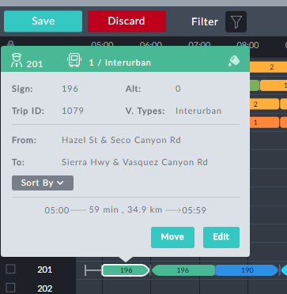

Suppose that it is found that on Sunday morning, most of the passengers boarding at

05:00 are children returning to school, resulting in a 7 minute delay. We will edit this trip to reflect the situation.

Ø**To change the trip times:**

1. Click **Edit** in the information box:

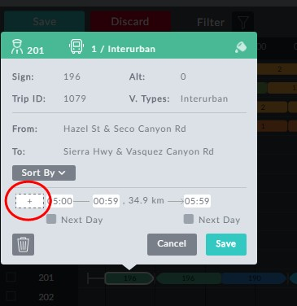

*Figure 1-3: Information box ready for editing*

All of the time fields are open for editing. In addition, the left hand time field (red circle) allows us to add time to the beginning of the trip by entering an earlier time than the shown trip start time.

2. By default it sets itself to the start time of 05:00. Enter 04:53.

3. Also extend the trip length by 5 min by increasing the shown length of 59 min to 64 min:

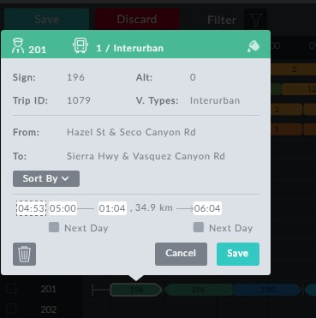

We could have changed the trip end time to 06:04 and the trip duration

would have been updated.

4. Click **Save**.



In **Figure 1-4** below, observe that changed trip element has a black dot indicating that it has been manually changed. Further, the duty block 201 is preceded by a blue change- bar. Notice also the red exclamation mark at the beginning of the row. It indicates a problem, that can be found from the bottom status line. Our edit has cause a problem as shown by the Duty Issues warning:

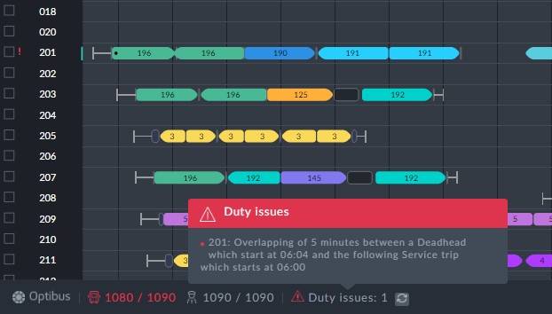

*Figure 1-4: Duty Issue caused by the edit*

Clicking the **Assign Vehicles** button commits the change to the loaded schedule (without

saving it). It does not solve the problem. The issue is only removed by running the optim- izer. The corresponding segment of the Drivers Gantt corresponding to **Figure 1-4**

above, looks quite different:

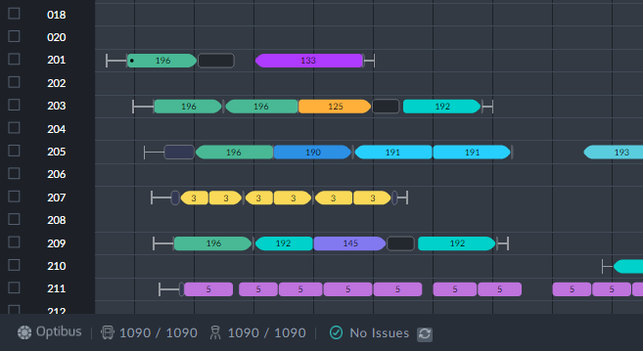

The point of all of this, is that a seemingly trivial change such as extending a trip by 5 min can have far-reaching effect on the overall schedule.

**Delete a trip or deadhead**

***Deleting a trip***

We will use the same example as in **Changing trip times** (the red-boxed trip in duty

201).

Ø**To delete a trip:**

1. In **Figure 1-3** above, click the button.



2. Click **Save**. You are asked to confirm:

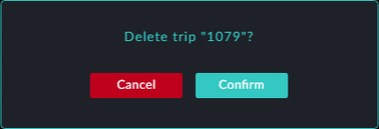

3. Click **Confirm** to accept the deletion.

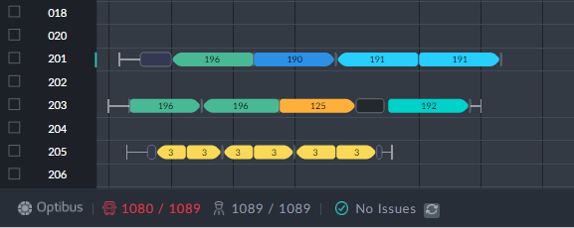

There is a pending change to the Vehicles Gantt for Vehicle 1 (no longer required to do

the deleted trip). If you look at the Vehicles Gantt, you will see that Vehicle 1 has been unassigned to the stack. Complete the change by clicking **Assign Vehicles**.

***Deleting a Deadhead***

Deleting deadheads follows the same pattern, however only editable deadheads may be deleted (see **What can and cannot be edited**).

**Switch between Taxi and Deadhead elements** Deadheads that can edited (see **What can and cannot be edited**) can be switched to a Taxi and vice versa. Again we will use Driver 201 in **Figure 1-1**. Immediiately following

the trip in the red box, there is a deadhead. Clicking it to open its information box, we

see this:

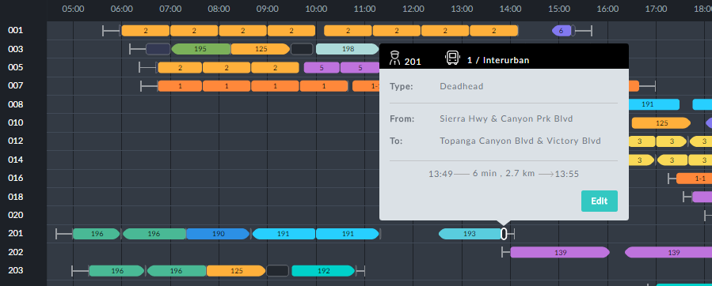

Open it for editing, and click the **Type** field:

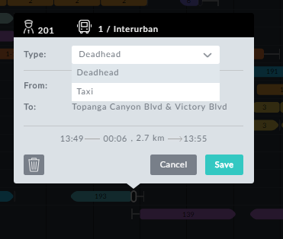

Change it to Taxi and save:

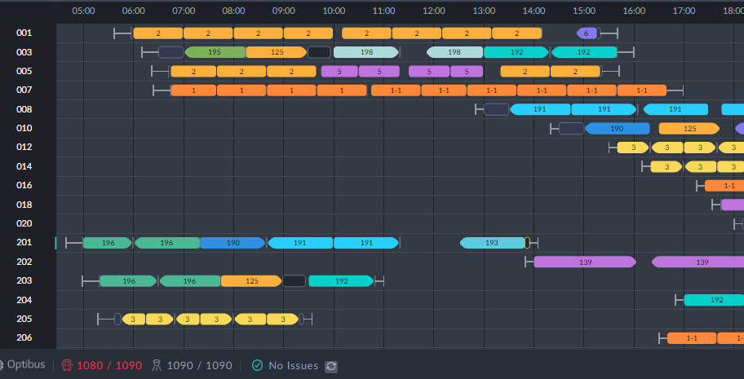

There is no visible change to the Gantt other than change-bar on duty 201 and the bot- tom left indicator that re-allocation for Vehicle 1 is required. Running a full **Assign Vehicles** (see **Using the Assign Vehicles Button**) leads to the result that the deadhead has been converted to a non-editable pull in - not at all what we expected:

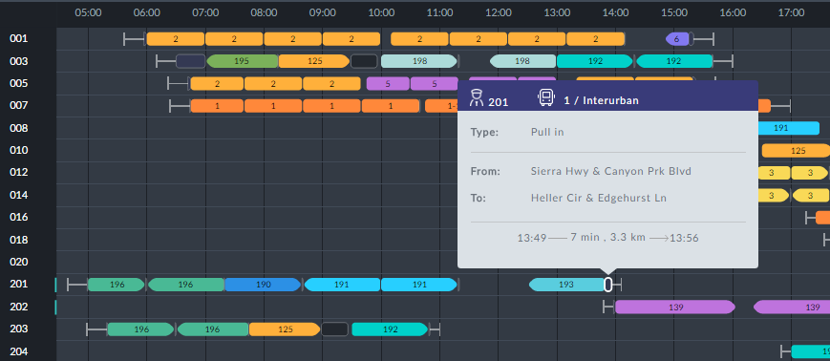

Oops! TBD

**Add new element**

***Adding a new element from an existing type***

You can add a new deadhead or taxi to the beginning and end of a duty. You can add a Taxi to either end of a split break. Eligible locations in the Drivers Gantt can be seen by hovering the mouse cursor at the beginning or end of a duty, a deadhead or a split. You will see a small button. Clicking it opens an editable window as in the following example:

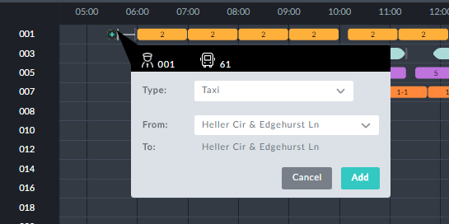

The **From:** field opens a drop-down list of eligible origin stops. The **Type:** field also offers a drop-down list:

*Figure 1-5: Choosing the "Taxi Type"*

You can either choose Taxi (or any other predefined available type) or create a new "Taxi Type" of your own. For now, leave it at Taxi and click **Add**. Apart from a change-bar, there is no visible change to the Drivers Gantt. Click **Assign Vehicles**. Nothing happens. Oops! TBD

***Adding a new element and a new type***

Continuing with **Figure 1-5**, we will choose New:

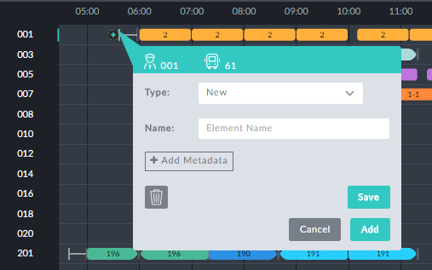

In the **Name:** field we enter a new type, Shuttle and then **Save**.



You can use the **Add** button to add more types. The one chosen will be

the last element name you enter.

**Adding Metadata** is an expert mode function for use in conjunction with

Optibus Professional Services

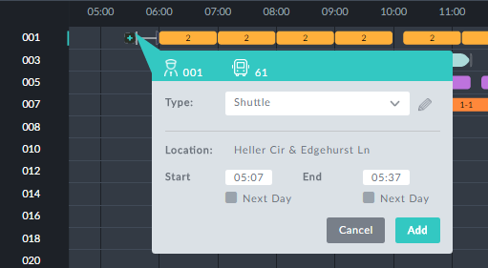

You can edit the Start and End times. We will leave as is and click **Add**. The Drivers Gantt

changes as follows:

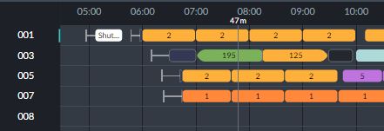

To confirm your edit, click the Shuttle information box:

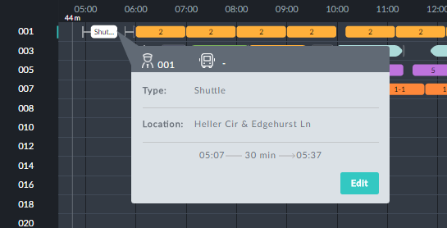

Notice also that the **Sign on** element has been moved back before the shuttle:

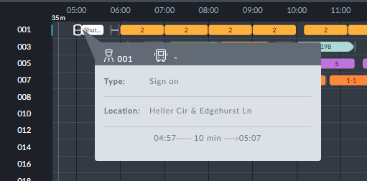

Complete the new assignment by clicking **Assign Vehicles**.

***Filling gaps between trips with a Taxi element***

Again using **Figure 1-5** and driver 201, click the gap between the last two trips, 191 and

193:



We are presented with an edit window:

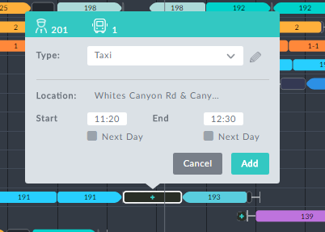

We can choose between Taxi an our own types:

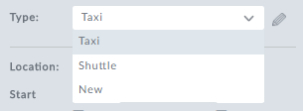

This time we leave the type as is and click **Add**. Here is the outcome:



Click the **Assign Vehicles** button to confirm the edit.

**Block level editing**

Using **Figure 1-5** and driver 201, click the block to display its information box:

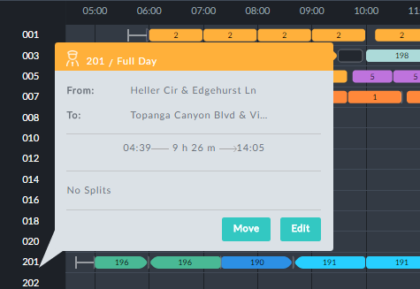

*Figure 1-6: Editing or moving a Driver block*

Click **Edit** to open it for editing:

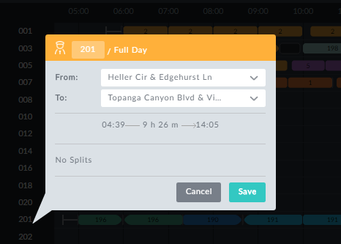

*Figure 1-7: Editing Driver block parameters*

***Change Duty ID***

In **Figure 1-6**, change the driver ID 20 2010 and save:

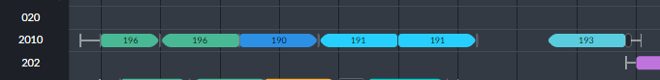

***Set Start/End stops***

The **From**: and **To:** fields are drop-down lists of eligible duty start and finish stops.



Choosing to new locations that are not "near" the existing locations (in the

sense of the **Places Grouping** preference) may seriously disrupt the sched- ule.

***Move a block up or down***

In **Figure 1-6** click **Move**. A horizontal blue cursor line is displayed:

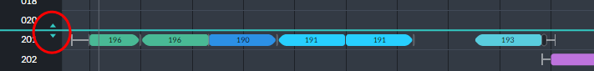

Place the mouse cursor on either of the up or down arrows (circled) and pull the blue cursor line to where you want the selected row (201) to be displayed. We have chosen to place it between rows 203 and 204:

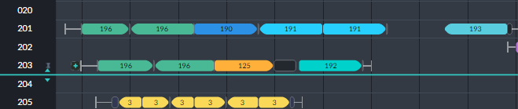

Releasing the mouse effects the change:

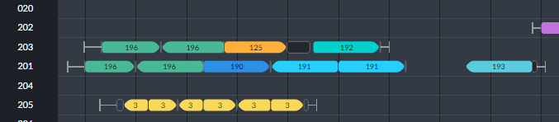

As usual, to commit these edits to the schedule, click **Assign Vehicles**.



Moving a Driver block is a convenient way of having it in a convenient pos-

ition on the screen. But it also determines the block priority during optim- ization (top to bottom).

**Edit Stack functions**

***De-assign a trip to the editing stack***

In the left side of **Figure 1-2**, double clicking the stack will de-assign the trip and move it to the stack:

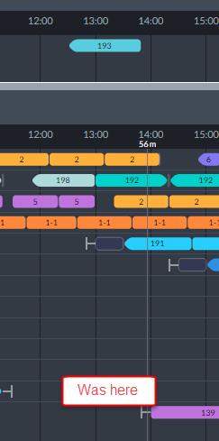

It is instructive to view the Vehicles stack area:



Vehicle 1 that originally did the trip we de-assigned is shown without it. A "temporary" vehicle (v_88) is assigned to the trip.

***Restore a trip to the editing stack***

To restore the trip in the previous example, it is sufficient to double click it and then click the target slot in the eligible trip slots:

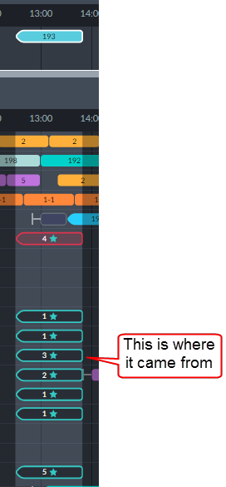

Click **Assign Vehicles** to commit your edits.

**Vehicles Gantt Interactive Editing**

**What can and cannot be edited**

Trips can have their start/end times edited or be removed completely



Deadheads can be removed completely



**Changing trip times**

The method is the same as for Driver trip elements.

**Delete a trip or deadhead**

Deleting a trip is the same as for Driver trip elements. Deleting a deadhead is a little dif- ferent. We have chosen a deadhead to remove:

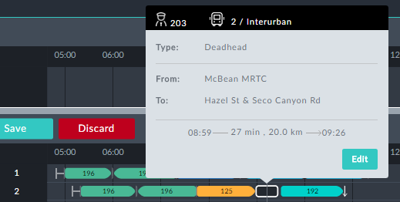

Clicking Edit opens the information box for editing:

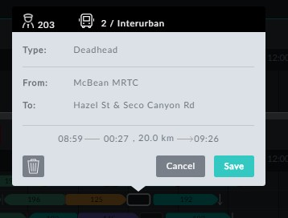

All that you can do here is remove the deadhead.



If you have enabled the **Deadheads Generator** preference, the deadhead

will be regenerated at the next optimization run.

**Block level editing**

In the Vehicles Gantt, clicking a Vehicle block number opens the bock information box:

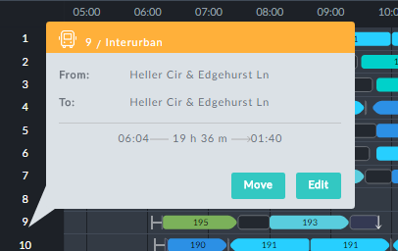

To open it for editing, click **Edit**:

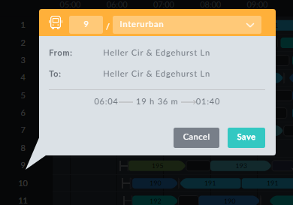

*Figure 1-8: Editing Vehicle block information box*

***Change Vehicle ID***

In **Figure 1-8**, you can change the Vehicle ID. You will be prevented from entering an ID

already in use. In this example, you could enter something like 9a.

***Change Vehicle Type***

Here you are offered a choice of Vehicle Types from those defined in the schedule.

***Move a block up or down***

This feature works the same way as it does for Driver blocks. The same priority con- sideration obtains here as well: The relative location of a Vehicle block in the Gantt sets its relative priority during optimization.

**Using Add Trip**

**Add Trip** is available from either Gantt display. To add a trip, click the plus sign button at the top left of the Stack area:

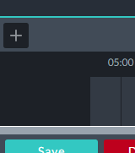

It open up the following dialog:

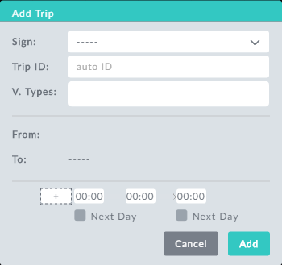

*Figure 1-9: Add Trip dialog*

To demonstrate the use of this feature, we start out with a segment of the Vehicles Gantt from the schedule we have used throughout this manual:

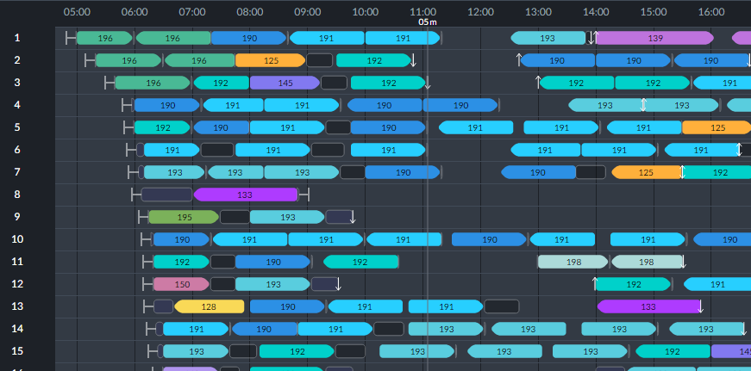

We will add an inter-urban trip for sign 192 at 10:35. Here is the filled out window of

**Figure 1-2**:

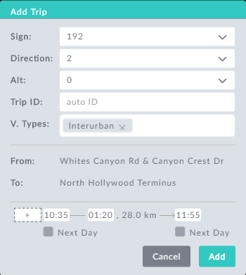

Here we set the direction, start time and trip duration. On clicking **Add**, we see the new trip in the editing stack ready for assignment:

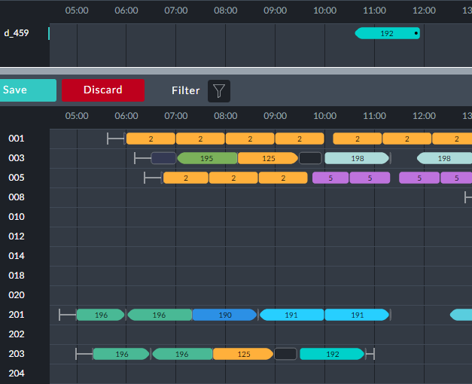

Ensure that the Drivers Gantt is visible and double click the new trip in the editing stack.

The list of allocation possibilities opens as we saw earlier in **Move a trip to another**

**Duty**. We have a good slot at duty 247:

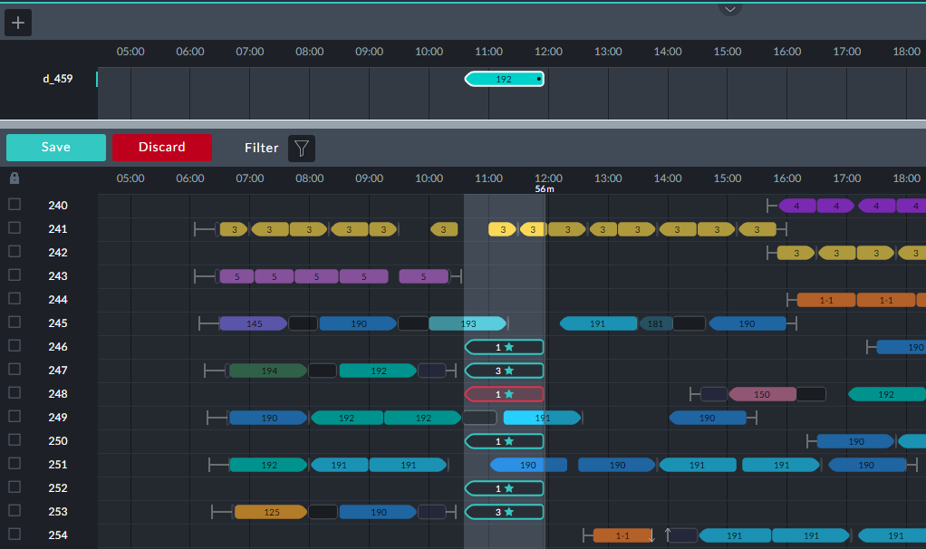

Clicking it offers the trip information box:

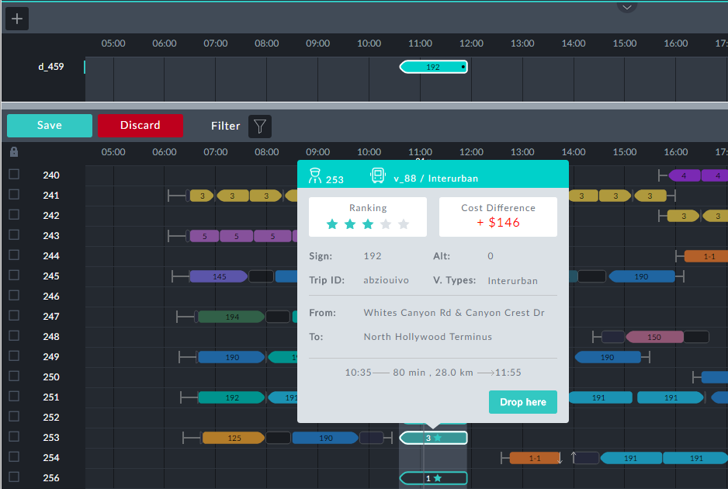

Click **Drop here**.



Double clicking the selected trip slot will also drop the new trip into place

without going through the information box.

We see that the trip has been assigned in the Drivers Gantt:

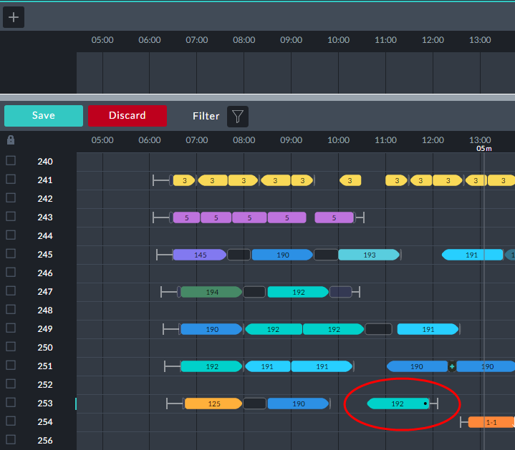

The new trip (circled) has been assigned to duty bock 253 and is marked with a black dot indicating that it is new or changed. Notice also the blue change-bar to the right of the duty block number.

We are not yet finished: Look at the Vehicles Gantt:

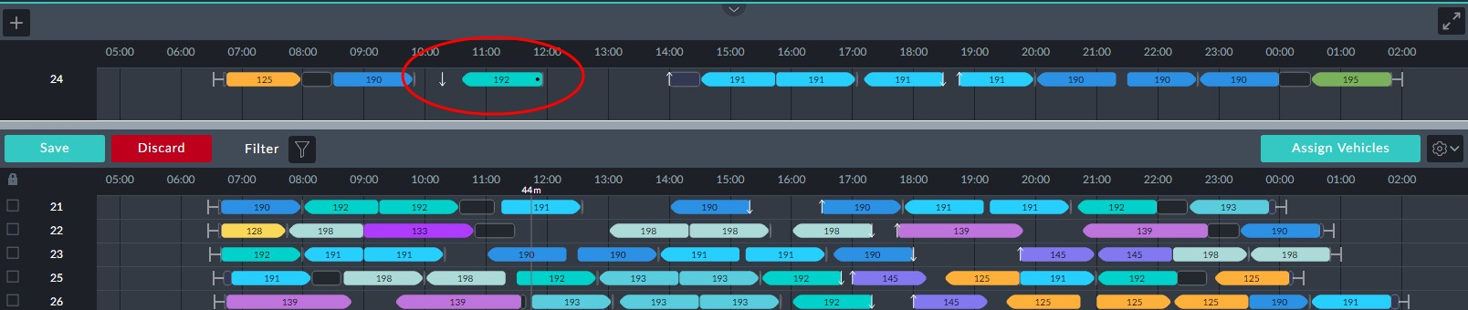

The vehicle block in the editing stack with the new trip (circled) tells us that the block is

"pending": We need to complete the allocation by clicking the but- ton. Doing so results in the asignment into the schedule of the new trip. Here is the rel- evant segment of the Vehicles Gantt -

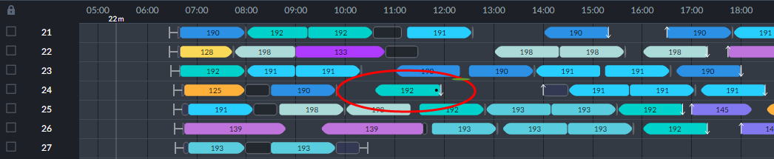

and of the Drivers Gantt:

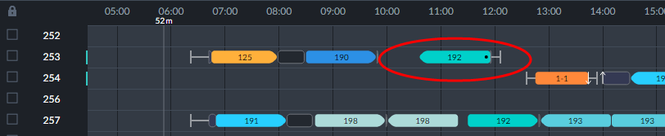

Notice the two blue change-bars indicating that duties 253 and 254 have been changed by the new assignment.



For advanced use of **Assign Vehicles**, see **Completing the Edit Session**.

**Using a Vehicles-only Schedule**

**What can and cannot be edited**

Trips can have their start/end times edited or be removed completely



Pull outs can be removed. Pull ins at the end of a day can be removed. Some mid day pull ins can be removed. Attempting to remove a mid day pull in unmatched by a prior pull out, will turn it in to a deadhead. Other end-day deadheads can be



removed. Otherwise, deadheads are not removable

Other deadheads, split breaks, pre/post and sign on/off elements cannot be edited



Block information boxes offer editable fields: Vehicle ID and type



**Move a trip to another Vehicle**

It is required to move the red-boxed trip in vehicle 5 in the Vehicles Gantt to a different vehicle:

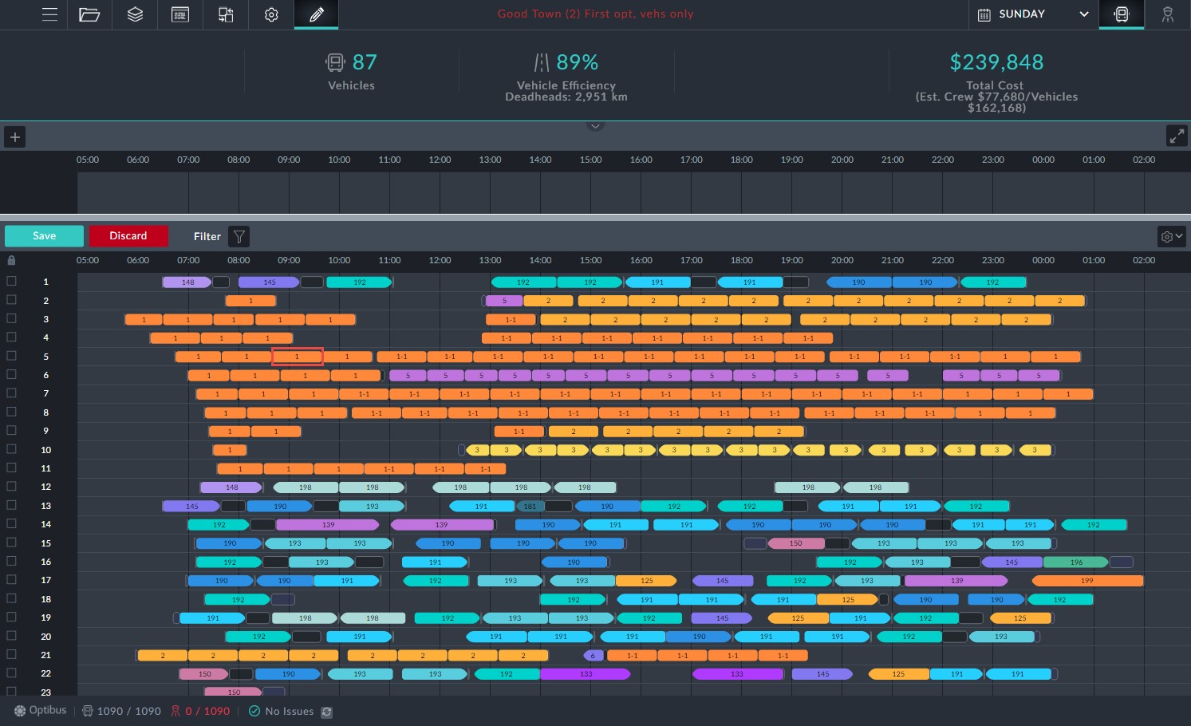

*Figure 1-10: Vehicles Gantt prepared for manual editing*

To do it, we must first be in manual editing mode as shown. Double clicking the trip shows a shaded area including possible trip slots as it did for moving trips in the Drivers Gantt. The system automatically recommends all possible options for relocation of the trip. The procedure for moving the trip here, is the same as in **Move a trip to another Duty**. We will not repeat the details here.

**Changing trip times**

Click a trip element for editing.

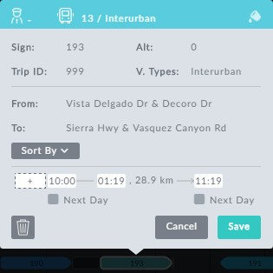

*Figure 1-11: Editing a vehicle through its information box*

Changing trip start/end times works the same way as it does for Drivers.

**Delete a trip or deadhead**

***Deleting aTrip***

We will use the same example as in **Changing trip times**. In **Figure 1-11** above, we click the button and then **Save**. You are asked to confirm the deletion.



***Deleting a Deadhead***

Deleting deadheads follows the same pattern, however only editable deadheads may be deleted (see **What can and cannot be edited**).

**Adding Deadheads**

If you mouse-over any gap between trips, you will see the icon in a "tentative" dead- head element (circled):

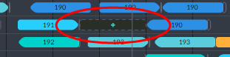

Clicking it opens an editable information box:

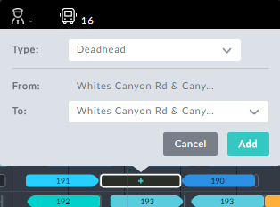

The type is a list of deadhead types. In this example only Deadhead is available. The

default **To:** stop is the same as the **From:** stop.



Choosing a new **To:**stop that is not "near" the **From:** stop (in the sense of

the **Places Grouping** preference) may seriously disrupt the schedule.

**Block level editing**

In the Vehicles Gantt, clicking a Vehicle block number opens the bock information box:



To open it for editing, click **Edit**:



*Figure 1-12: Editing Vehicle block information box*

***Change Vehicle ID***

In **Figure 1-8**, you can change the Vehicle ID. You will be prevented from entering an ID

already in use. In this example, you could enter something like 9a.

***Change Vehicle Type***

Here you are offered a choice of Vehicle Types from those defined in the schedule.

***Move a block up or down***

This feature works the same way as it does for Driver blocks. The same priority con- sideration obtains here as well: The relative location of a Vehicle block in the Gantt sets its relative priority during optimization.

**Completing the Edit Session**

**Using the Assign Vehicles Button**

To complete the session you must click the button. An advanced usage is available by opening button's context menu:

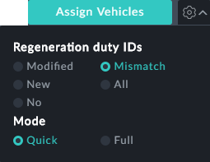

**Regeneration duty IDs**

If you have moved trips or added new elements you will have to regenerate some or all of the duty IDs. You can choose between the following:

Modified



New No Mismatch All



**Mode:**

Quick: Full:

